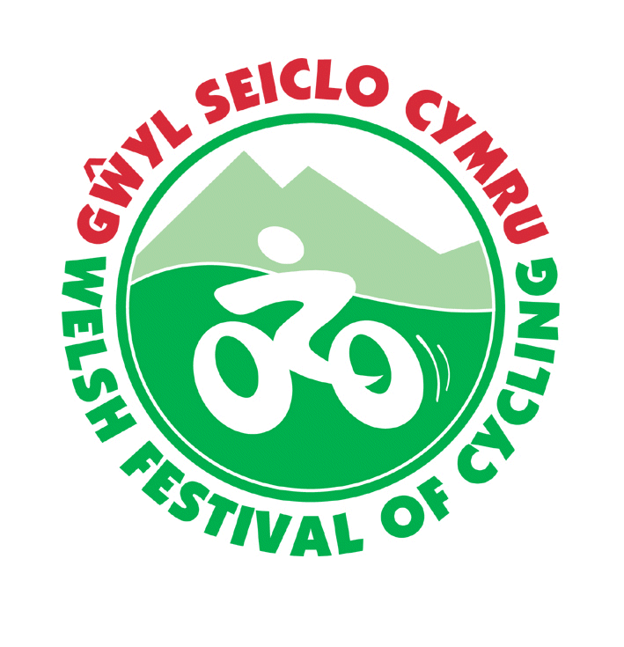
Welsh Festival of Cycling
CTC Cymru
Gŵyl Seiclo Cymru
Booking Form
Thursday 18th to Tuesday 23th July 2019
Clwb Rygbi Rhuthun Ruthin Rugby Club

Please complete this form in block capitals and return it to:
Welsh Festival of Cycling 2019, 8 St Chad’s Close, Wellington, Telford, Shropshire TF1 3EW
Please register the following persons for the Welsh Festival:
 | Surname | First name | Title | Cycling UK membership number | Child/  Student
1
2
3
4
5
6

Registration Booking:- | Number | Price | Cost
Adult registration |  | £15
Children under 16or f/t students under 21 |  | £2
TOTAL REGISTRATION FEES (non-refundable)

Your name and the address to which all correspondence should be sent:
Name:....................................................................................................
Address:...................................................................................................................................................................................................................................................................................................................................................................................................................................................................................
Phone: day..........................................Evening...................................Mob..........................

Email.........................................................................................................................................

Emergency Contact: Name..................................... Contact number......................

CAMPING
Number of pitches required. Tents.................... Caravan/Motor home..............................
The campsite package is for Thursday through to Monday night.
If you are booking on the basis of single nights please circle which nights

Thursday Friday Saturday Sunday Monday

 | Number | Price per  unit | Cost
Tents
Number of pitches (includes one adult camping per pitch) |  | £30.00
Additional adults on the same pitch (per adult) |  | £16.00
Registered children – camp free with accompanying adult
Camping pitch- single nights includes one adult |  | £7.00
- Single night additional adult |  | £4.00
Caravans/Motor Homes
Number of pitches (includes one adult camping per pitch) |  | £35.00
Additional adults on the same pitch (per adult) |  | £20.00
Registered children – camp free with accompanying adult
Caravan/Motor home - single nights includes one adult |  | £8.00
- Single night additional adult |  | £5.00
Total camping

Summary of costs | Cost
Registration fees
Camping fees
Final total

I enclose a cheque for £_________ made payable to CTC Cymru
(please do not send cash)
Signature...........................................................Name...............................Date....................
Please send the completed form to:
Welsh Festival of Cycling 2019, 8 St Chad’s Close, Wellington, Telford, Shropshire TF1 3EW

Please accept cashing of your cheque as confirmation of booking

